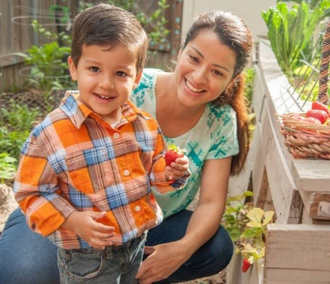
Future
Building for the
This child care receives Federal cash assistance to serve healthy meals to your children. Good nutrition today means a stronger tomorrow!









Meals served here must meet nutrition requirements established by USDA’s Child and Adult Care Food Program.
Your child care at
Call USDA at
1-866-873-2263
Food and Nutrition Division at
1-800-
TELL-TDA
(835-5832)
OR
Fraud Hotline: 1-866-5-FRAUD-4 or 1-866-537-2834 | P.O. Box 12847 | Austin, TX 78711
Toll Free: (877) TEX-MEAL | For the hearing impaired: (800) 735-2989 (TTY)
Food and Nutrition Division
Child and Adult Care Food Program
This product was funded by USDA
.
This institution is an equal opportunity provider
.
Updated 11/17/2021
www.SquareMeals.org
Contact Information: First Step Learning Centre
Address: 5641 Southwestern Medical Ave. Dallas , Texas 75235
Phone Number: 214-352-8608
Email Address: firststeplearningcentre@gmail.com
Other Necessary Information:
una manana mas fuerte.

