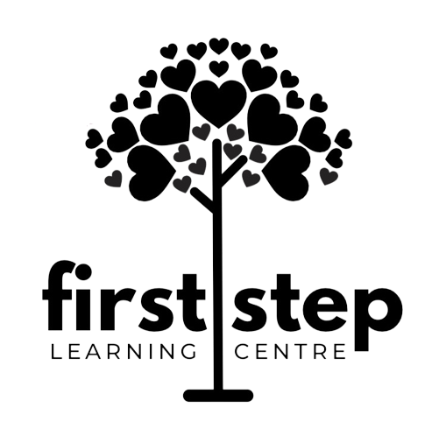
Photography Consent Form
First Step Learning Centre sometimes takes photographs or video during normal day-to-day activities or special events. These images may appear on our social medias, school bulletin boards, in newsletters, or on our website. Photography of enrolled children and the use of images of enrolled children at First Step require parental permission. If you prefer that your child not be photographed or that images of your child not be used for the said purposes; please indicate this below. It is our policy to not photograph or use images of children for which we do not have parental consent.
Please answer the following questions about the use of photographs of your child. Circle YES or NO for each question.

YES / NO May we photograph your child during normal day-today activities and special events?

YES / NO May images of your child be used on school bulletin boards?

YES / NO May images of your child be used on our website and/or our socials?

CHILD NAME: ______________________ PARENT NAME (PRINT): ______________________

PARENT SIGNATURE: ________________________ DATE: _______________________________

