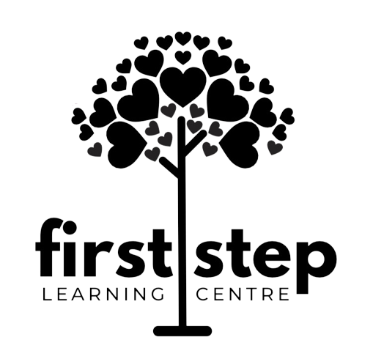

First Step Learning Centre
5641 Southwestern Medical Ave
Dallas, TX 75235

Although First Step Learning Centre is open to the public and privately owned, we are located on the campus of UT Southwestern and because so, we are required each month to report each our parents who are employed by UT Southwestern. This is to ensure employees are benefiting from the daycare. If you are employed by UT Southwestern, please fill out the following information or bring your badge in for us to make a copy of your employee identification number.
If both parents work at UT Southwestern, please provide both parents information. Thanks in advance!

UT Southwestern Employee Name: _____________________________

UT Southwestern Employee ID Number: _________________________

Child’s Name: ______________________________________________

Date: ____________________________________________________________

