Form 2935
January 2025


Admission Information
Use this form to collect all required information about a child enrolling in day care.
Directions: The day care provider gives this form to the child’s parent or guardian. The parent or guardian completes the form in its entirety and returns it to the day care provider before the child's first day of enrollment. The day care provider keeps the form on file at the child care facility.
General Information
Operation’s Name: |  | Director's Name:
Child's Full Name: |  | Child's Date of Birth: | Child Lives With:  Both parents Mom Guardian  Dad
Child's Home Address: |  | Date of Admission: |  |  |  | Date of Withdrawal:
Name of Parent or Guardian 1: |  | Address of Parent or Guardian 1 if different from the child's:
Name of Parent or Guardian 2: |  | Address of Parent or Guardian 2 if different from the child's:
List phone numbers below where parents or guardian may be reached while child is in care.
Parent 1 Area Code and Phone No.: | Parent 2 Area Code and Phone No.: | Guardian's Area Code and Phone No.: |  |  | Custody Documents on File:  No  Yes
In case of an emergency, when the parent or guardian cannot be reached, call:
Name of Emergency Contact: |  | Relationship: |  |  | Area Code and Phone No.:
Address:
I authorize the child care operation to release my child to leave the child care operation only with the following persons. Please list name and phone number for each. Children will only be released to a parent or guardian or to a person designated by the parent or guardian after verification of ID.
Name: |  |  |  | Area Code and Phone No.:
Name: |  |  |  | Area Code and Phone No.:
Name: |  |  |  | Area Code and Phone No.:
Consent Information
1. Transportation:
I give consent for my child to be transported and supervised by the operation's employees. Check all that apply.
for emergency care on field trips to and from home to and from school
2
I give consent for my child to participate in field trips.
I do not give consent for my child to participate in field trips.
Comments:
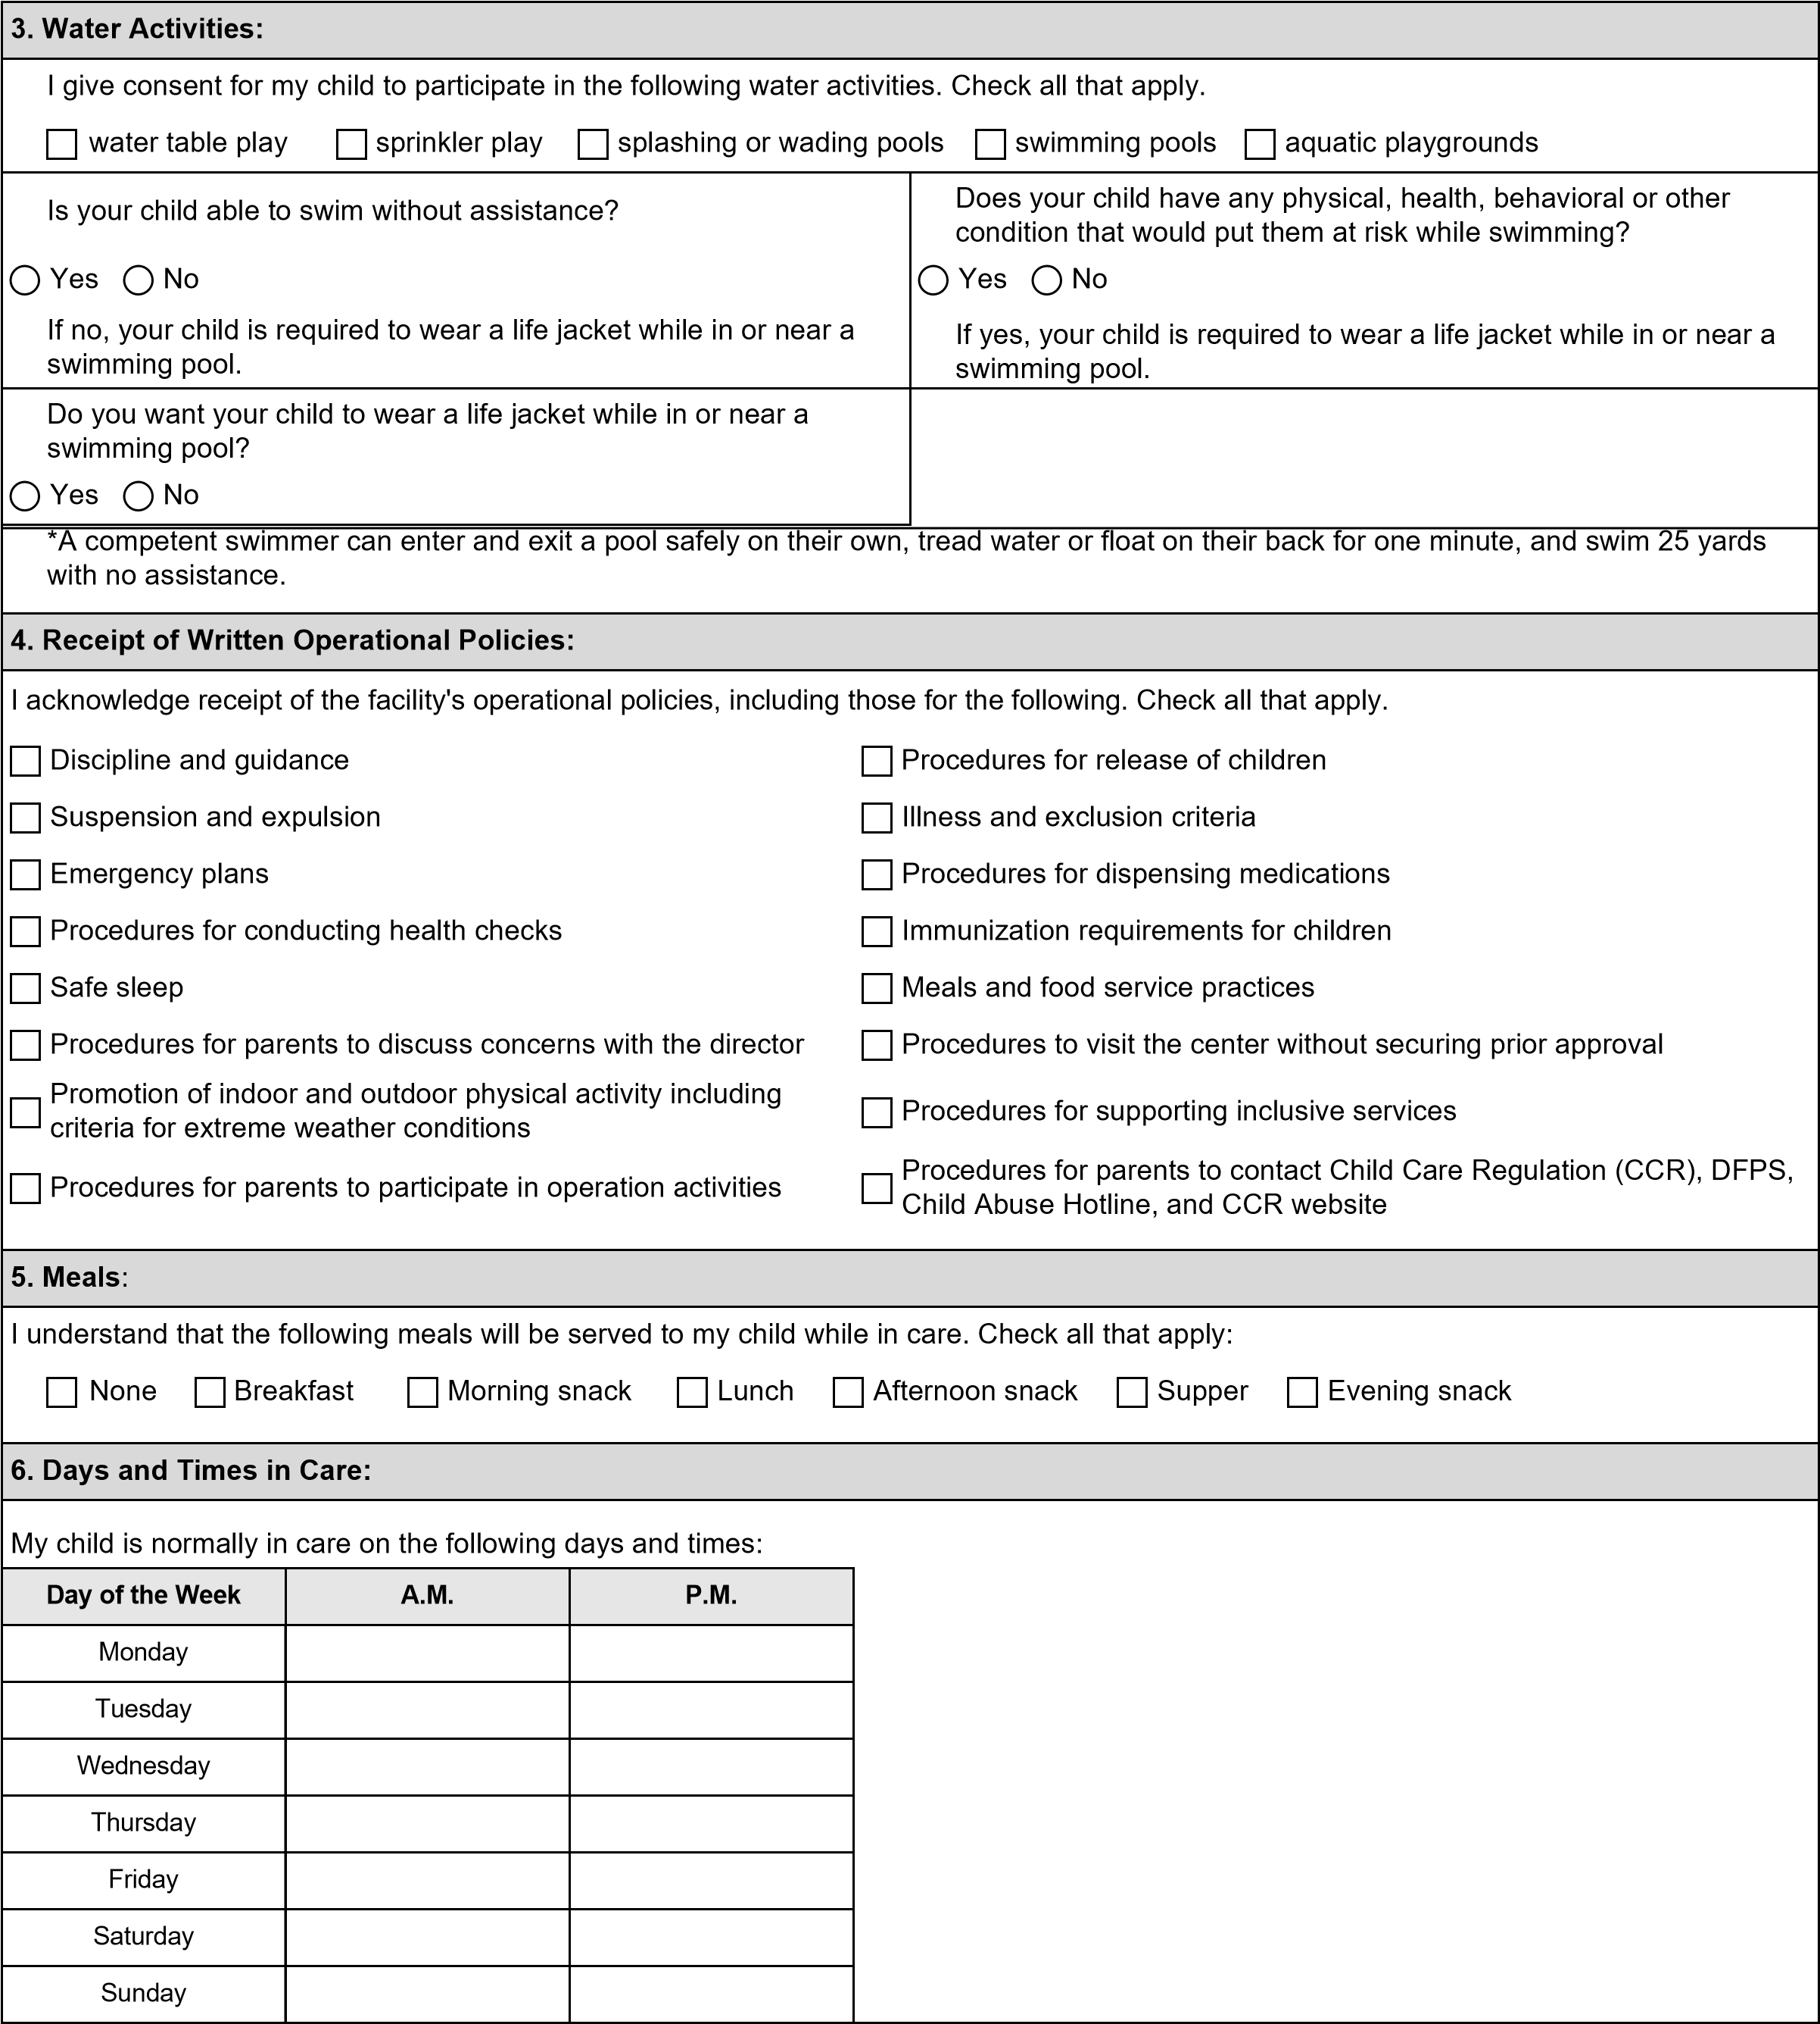
7. Receipt of Parent’s Rights:
I acknowledge I have received a written copy of my rights as a parent or guardian of a child enrolled at this facility.

Signature — Parent or Legal Guardian Date Signed
. Child's Special Care Needs, check all that apply
8
Environmental allergies
Limitations or restrictions on child's activities
Food intolerances
Reasonable accommodations or modifications
Existing illness
Adaptive equipment, include instructions below
Previous serious illness
Symptoms or indications of complications
Injuries and hospitalizations in the past 12 months
Medications prescribed for continuous long-term use
Other:
Explain any needs selected above:
Does your child have diagnosed food allergies?
Yes
No
Food Allergy Emergency Plan Submitted Date:
Child day care operations are public accommodations under the Americans with Disabilities Act (ADA), Title III. To learn more, visit

www.ada.gov/resources/child-care-centers/
. If you believe that such an operation may be practicing discrimination in violation of Title III, you
may call the ADA Information Line at (800) 514-0301 (voice) or (800) 514-0383 (TTY).
Signature — Parent or Legal Guardian
Date Signed
9
. School Age Children
My child attends the following school:
School Area Code and Phone No.:
My child has permission to:
Check all that apply.
walk to or from school or home
ride a bus
be released to the care of their sibling younger than 18 years old
A
uthorized pick up or drop off locations other than the child’s address:
Child's required immunizations, vision and hearing screening, and TB screening are current and on file at their school.
Authorization For Emergency Medical Attention
In the event I cannot be reached to arrange for emergency medical care, I authorize the person in charge to take my child to:
Name of Physician | Address | Area Code and Phone No.
Name of Emergency Care Facility | Address | Area Code and Phone No.
I give consent for the facility to secure any and all necessary emergency medical care for my child.

Signature — Parent or Legal Guardian Date Signed

Requirements for Exclusion from Compliance
I have attached a signed and dated affidavit stating that I decline immunizations for reason of conscience, including religious belief, on the form described by Section 161.0041 Health and Safety Code submitted no later than the 90th day after the affidavit is notarized.
I have attached a signed and dated affidavit stating that the vision or hearing screening conflicts with the tenets or practices of a church or religious denomination that I am an adherent or member of.
 |  |  |  |  |  | Vision Exam Results
Right Eye 20/ |  |  | Left Eye 20/ | Pass |  | Fail  Date Signed
Signature
 |  |  |  |  | Hearing Exam Results
Ear |  | 1000 Hz |  |  | 2000 Hz |  | 4000 Hz | Pass or Fail
Right |  |  |  |  |  |  |  | Pass Fail  Pass Fail
Left |  |  |  |  |  |  |  | Pass Fail  Pass Fail
Signature |  |  |  |  | Date Signed
 | Admission Requirement
If your child does not attend pre-kindergarten or school away from the child care operation, one of the following must be presented when your child is admitted to the child care operation or within one week of admission. Select only one option.
Health Care Professional’s Statement: I have examined the above named child within the past year and find they are able to take part in the day care program.
A signed and dated copy of a health care professional's statement is attached.
Medical diagnosis and treatment conflict with the tenets and practices of a recognized religious organization, which I adhere to or am a member of. I have attached a signed and dated affidavit stating this.
My child has been examined within the past year by a health care professional and is able to participate in the day care program. Within 12 months of admission, I will obtain a health care professional's signed statement and submit it to the child care operation.
Name of Health Care Professional, if selected Address of Health Care Professional, if selected

Signature — Health Care Professional Date Signed

Signature — Parent or Legal Guardian Date Signed

Vaccine Information
The following vaccines require multiple doses over time. Provide the date your child received each dose.
Vaccine | Vaccine Schedule | Dates Child Received Vaccine
Hepatitis B | Birth (first dose)
Hepatitis B | 1–2 months (second dose)
Hepatitis B | 6–18 months (third dose)
Rotavirus | 2 months (first dose)
Rotavirus | 4 months (second dose)
Rotavirus | 6 months (third dose)
Diphtheria, Tetanus, Pertussis | 2 months (first dose)
Diphtheria, Tetanus, Pertussis | 4 months (second dose)
Diphtheria, Tetanus, Pertussis | 6 months (third dose)
Diphtheria, Tetanus, Pertussis | 15–18 months (fourth dose)
Diphtheria, Tetanus, Pertussis | 4–6 years (fifth dose)
Haemophilus Influenza Type B | 2 months (first dose)
Haemophilus Influenza Type B | 4 months (second dose)
Haemophilus Influenza Type B | 6 months (third dose)
Haemophilus Influenza Type B | 12–15 months (fourth dose)
Pneumococcal | 2 months (first dose)
Pneumococcal | 4 months (second dose)
Pneumococcal | 6 months (third dose)
 | 12–15 months (fourth dose)
Inactivated Poliovirus | 2 months (first dose)
Inactivated Poliovirus | 4 months (second dose)
Inactivated Poliovirus | 6–18 months (third dose)
Inactivated Poliovirus | 4–6 years (fourth dose)
Influenza | Yearly, starting at 6 months. Two doses given at least four weeks apart are recommended for children who are getting the vaccine for the first time and for some other children in this age group.
Measles, Mumps, Rubella | 12–15 months (first dose)
Measles, Mumps, Rubella | 4–6 years (second dose)
Varicella | 12–15 months (first dose)
Varicella | 4–6 years (second dose)
Hepatitis A | 12–23 months (first dose)
Hepatitis A | The second dose should be given six to 18 months after the first dose.

Varicella for Chickenpox
Varicella, the vaccine for chickenpox, is not required if your child has had chickenpox disease. If your child has had chickenpox, complete the statement: My child had varicella disease, chickenpox, on or about [date] and does not need varicella vaccine.

Signature Date Signed
Additional Information About Immunizations
For additional information about immunizations, visit the Texas Department of State Health Services website at www.dshs.state.tx.us/ immunize/public.shtm.
 |  | TB Test if required
Positive | Negative | Date:
Gang Free Zone
Under the Texas Penal Code, any area within 1,000 feet of a child care center is a gang-free zone, where criminal offenses related to organized criminal activity are subject to harsher penalties.
Privacy Statement
HHSC values your privacy. For more information, read our privacy policy online at https://hhs.texas.gov/policies-practices-privacy#security
Signatures
Child's Parent or Legal Guardian Date Signed

Center Designee Date Signed
Physician or Public Health Personnel Verification
Signature or stamp of a physician or public health personnel verifying immunization information above:

Signature Date Signed

